**Creating Applications with Source-to-Image**

**The Source-to-Image (S2I) Process**

Source-to-Image (S2I) is a tool that makes it easy to build container images from application

source code. This tool takes an application's source code from a Git repository, injects the source

code into a base container based on the language and framework desired, and produces a new

container image that runs the assembled application

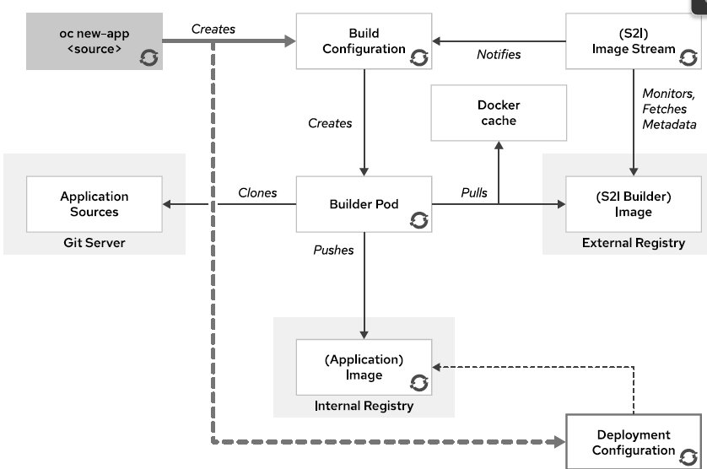

S2I is the primary strategy used for building applications in OpenShift Container Platform.

The main reasons for using source builds are:

• **User efficiency**: Developers do not need to understand Dockerfiles and operating system

commands such as yum install. They work using their standard programming language tools.

• **Patching**: S2I allows for rebuilding all the applications consistently if a base image needs a

patch due to a security issue. For example, if a security issue is found in a PHP base image, then

updating this image with security patches updates all applications that use this image as a base.

• **Speed:** With S2I, the assembly process can perform a large number of complex operations

without creating a new layer at each step, resulting in faster builds.

• **Ecosystem**: S2I encourages a shared ecosystem of images where base images and scripts can

be customized and reused across multiple types of applications.

How to check available image streams:

[root@workstation ~]# oc get is –n openshift

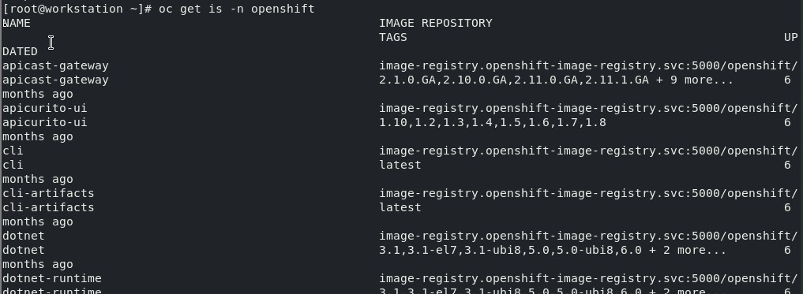

**If you want get the particular version:**

[root@workstation ~]# oc get is –n openshift | grep “php”



Building an Application with S2I and the CLI

An application can be created using the S2I process with the oc new-app command from the

CLI:

[root@workstation ~]# oc new-app --name <nameof tag> -i php:7.3 <https://github.com/RedhatTraining/DO180-app.git> --context-dir php-helloworld

-i It will specific the particular version

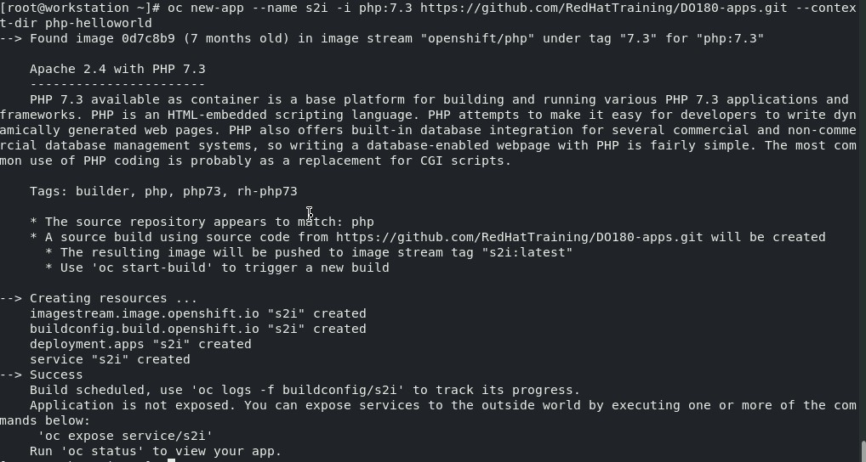

At time of build if see the logs . it will show every thing

[root@workstation ~]# oc get pods

[root@workstation ~]# oc logs –f <pod name>

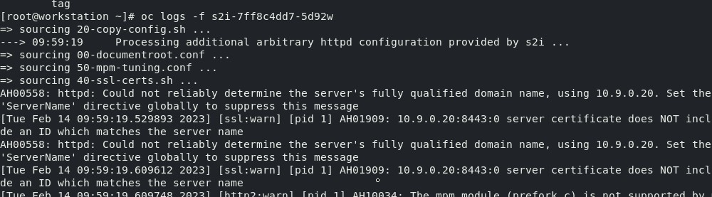

After creating a new application, the build process starts. Use the oc get builds command to

see a list of application builds:

[root@workstation ~]# oc get build

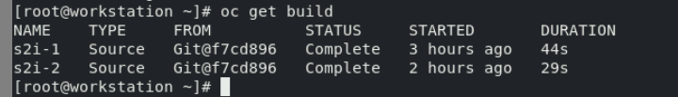

OpenShift allows viewing the build logs

[root@workstation ~]# oc log build/buildname

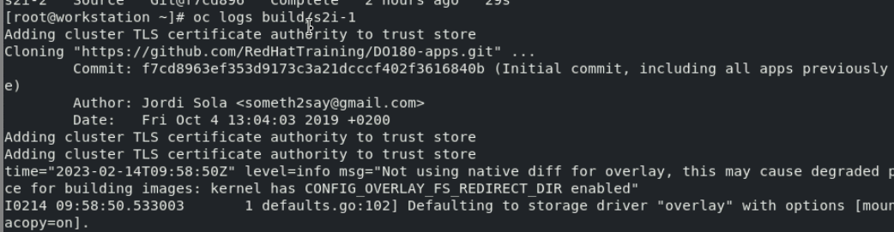

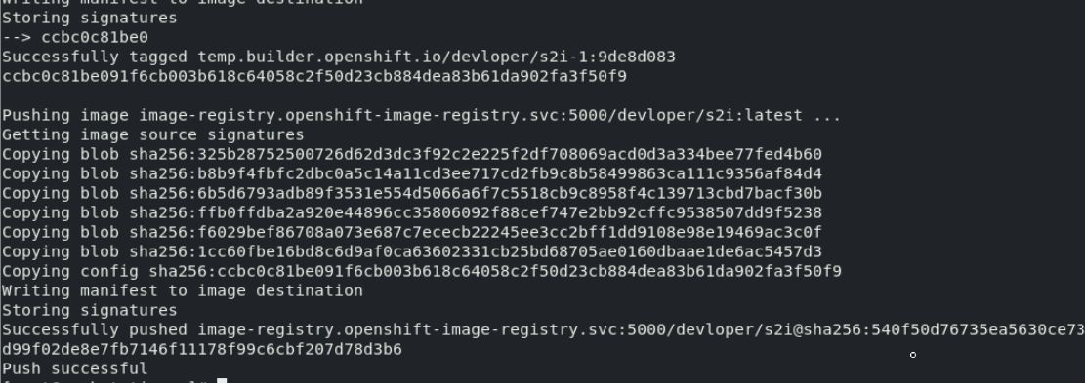

**Upload the build image to openshift internal registry**



Trigger a new build with the oc start-build *build-config-name* command:

[root@workstation ~]# oc get buildconfig

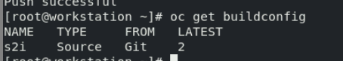

In if we made any changes the code in github it won’t be apply .we need to run a command to apply the changes the s2i

Now rebuild the image

[root@workstation ~]# oc get build



[root@workstation ~]# oc start-bulid <namebuildimage>

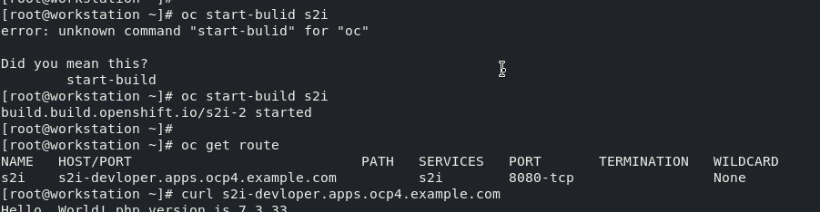

Output

[root@workstation ~]# curl < route url>

